Healthcare Provider Fraud Detection Analysis — Technical Assessment
This is the Kaggle CMS Medicare 2009 derivative (Rohit Anand Gupta / rohitrox/healthcare-provider-fraud-detection-analysis). It is a well-known, structured healthcare billing dataset with 558K+ claims and provider-level fraud labels. It supports graph-based fraud research, but with important caveats relative to your project goal of claim-level, explainable GNN anomaly detection.

1. Available Entities
Project Entity | Present? | Dataset Representation | Notes
Patient | Yes | BeneID in beneficiary + claim files | 138,556 train beneficiaries; demographics, chronic conditions, geography
Doctor | Partial | AttendingPhysician, OperatingPhysician, OtherPhysician | ~100,737 unique physician IDs; role-specific, not unified doctor profile
Hospital | No | — | No hospital/facility ID or name; Provider is the billing entity
Insurance Claim | Yes | ClaimID | 558,211 train claims (40K inpatient, 518K outpatient)
Treatment | Proxy only | ICD-9 diagnosis codes (ClmDiagnosisCode_*, ClmAdmitDiagnosisCode, DiagnosisGroupCode) + procedure codes (ClmProcedureCode_*) | 11,710 diagnosis codes, 1,324 procedure codes; only 4.2% of claims have procedure codes
File Structure
File | Rows | Role
Train-*.csv / Test-*.csv | 5,410 / 1,353 | Provider IDs + train-only fraud label
Train_Beneficiarydata-*.csv | 138,556 | Patient static features
Train_Inpatientdata-*.csv | 40,474 | Inpatient claims
Train_Outpatientdata-*.csv | 517,737 | Outpatient claims
Test equivalents | 135,392 claims | No fraud labels
Entity Cardinality (Train)
Entity | Count
Providers | 5,410
Beneficiaries | 138,556
Claims | 558,211
Physicians (non-null) | 100,737
Diagnosis codes | 11,710
Procedure codes | 1,324
Provider in this dataset is a de-identified billing organization (physician group, DME supplier, lab, etc.) — not equivalent to “hospital” in your schema. Treat it as Healthcare Provider / Billing Entity.

2. Possible Graph Nodes
Core nodes (recommended)
Node Type | Key | Feature Sources
Beneficiary | BeneID | Age (from DOB), gender, race, state/county, 11 chronic conditions, annual reimbursement/deductible aggregates
Provider | Provider | Aggregated claim stats, reimbursement patterns, specialty proxies from code distributions
Claim | ClaimID | Amount, dates, duration, deductible, claim type (IP/OP)
Physician | PHY* IDs | Claim volume, role type, co-provider affiliations
Diagnosis | ICD-9 codes | Code embedding or one-hot; can be shared across claims
Procedure | Procedure codes | Sparse; use only if modeling treatment pathways
Optional / derived nodes
Node Type | Derivation | Use Case
State / County | State, County from beneficiary | Geographic fraud clustering
DiagnosisGroup | DiagnosisGroupCode (inpatient) | DRG-level inpatient analysis
TimePeriod | Month/quarter from ClaimStartDt | Temporal GNN or snapshot graphs (2008-11 to 2009-12)
Mapping to your project schema
Patient → Beneficiary (BeneID) ✓ Full
Doctor → Physician (PHY*) ✓ Partial (no credentials, specialty)
Hospital → Not available ✗ Must omit or proxy via Provider
Claim → ClaimID ✓ Full
Treatment → Diagnosis + Procedure codes ~ Proxy (not atomic treatment events)

3. Possible Graph Edges
Directly observable edges
Edge Type | Source → Target | Count (Train) | Attributes
submitted_by | Beneficiary → Claim | 558,211 | —
billed_by | Claim → Provider | 558,211 | InscClaimAmtReimbursed, DeductibleAmtPaid
attended_by | Claim → Physician | 556,703 (attending) | Role: attending / operating / other
has_diagnosis | Claim → Diagnosis | ~1.83M (all positions) | Position rank (1–10), primary vs secondary
has_procedure | Claim → Procedure | ~23K claims | Sparse
affiliated_with | Physician → Provider | 87,905 unique pairs | Co-occurrence frequency, first/last seen date
treated_by | Beneficiary → Provider | 363,300 unique pairs | Aggregated edge weight (claim count, total reimb.)
Derived / higher-order edges
Edge Type | Construction | Research Value
shares_patient | Provider ↔ Provider | Co-billing networks; fraud ring detection
shares_physician | Provider ↔ Provider | Collusion patterns (5,219 physicians serve >1 provider)
shares_diagnosis | Provider ↔ Provider | Upcoding / diagnosis padding similarity
co_occurs | Diagnosis ↔ Diagnosis | Comorbidity structure on same claim
Relational statistics
- 66.2% of patients visit more than one provider → rich cross-provider connectivity.
- 42.6% of beneficiaries appear in claims from both fraud and non-fraud providers → bridges between classes (useful for GNN, risky for leakage).
- Fraud providers (median): 155 claims, 117 patients, 23 physicians, $373K total reimbursement vs non-fraud: 27 / 22 / 5 / $15K.

4. Heterogeneous Graph Feasibility
Yes — a heterogeneous graph can be constructed robustly.
Minimum viable heterogeneous schema:

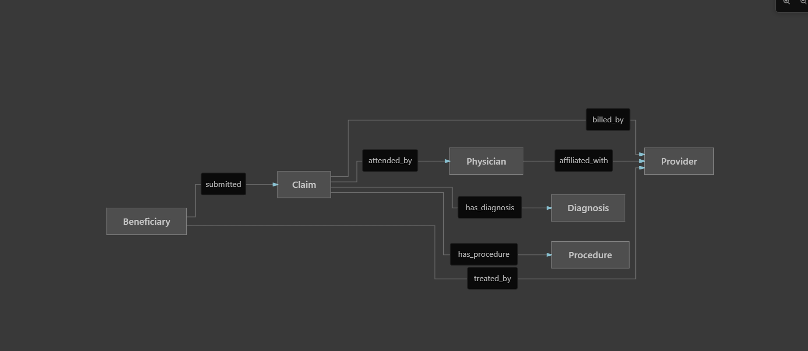

Node type count: 5–7 types
Edge type count: 6–10 types (including derived meta-paths)
Construction approaches
Approach | Description | Best For
Claim-centric bipartite+ | Claim as hub connecting patient, provider, physician, codes | Fine-grained relational learning
Provider-centric ego-graph | Provider at center; patients, physicians, codes as neighbors | Matches label granularity
Temporal snapshots | Monthly graphs with cumulative edges | Detecting billing bursts
Meta-path graph | e.g., Provider–Patient–Provider, Provider–Physician–Provider | HAN / HGT-style models
Framework fit: PyG HeteroData, DGL heterograph, or Neo4j for exploratory analysis.

5. Fraud Labels
Aspect | Status
Labels exist? | Yes, training set only
Label column | PotentialFraud ∈ {Yes, No}
Granularity | Provider-level, not claim-level
Distribution | 506 fraud / 4,904 non-fraud → 9.35% positive rate (imbalanced)
Test labels | Withheld — test file contains only Provider IDs (Kaggle competition format)
Label provenance | Undocumented — not adjudicated fraud; likely CMS/OIG “potential fraud” flag without charge/conviction stage
Critical implication for your project
Your project_context.md targets “fraudulent insurance claims”, but labels identify fraudulent providers. All claims from a flagged provider inherit the label only by association — there is no ground-truth claim-level fraud annotation.
Workable formulations:
- Provider classification (native task) — predict PotentialFraud from provider ego-graph.
- Weak claim labels — propagate provider label to all its claims (noisy, not publishable as claim fraud without caveats).
- Anomaly detection — treat unlabeled claims/providers as unlabeled; use graph autoencoder on non-fraud providers, flag outliers (aligns with your hybrid anomaly + GNN pipeline).
- Self-supervised pretrain + provider fine-tune — learn claim embeddings, aggregate to provider for labeled task.

6. Are Graph Neural Networks Appropriate?
Yes, with scoped expectations.
Why GNNs fit
Factor | Assessment
Multi-entity interactions | Patients, physicians, providers, codes form natural relational structure
Fraud as collective behavior | Provider fraud often involves patient panels, physician networks, diagnosis patterns
Hidden patterns | GNNs can learn non-linear combinations of neighborhood statistics beyond tabular aggregates
Explainability tooling | GNNExplainer, PGExplainer, heterogeneous subgraph extraction align with project goals
Scale | ~560K edges is manageable for GraphSAGE, GAT, HGT, R-GCN
Recommended model strategy
Task Alignment | Model | Rationale
Provider fraud (native labels) | HGT, R-GCN, HetGNN | Multiple node/edge types
Scalable baseline | GraphSAGE on Provider–Patient–Physician subgraph | Efficient inductive learning
Anomaly component | Graph Autoencoder or DOMINANT on non-fraud providers | Unsupervised deviation scoring
Explainability | GNNExplainer + SHAP on aggregated node features | Dual-level explanations
When GNNs add value over tabular ML
GNNs are justified if you can demonstrate gains from relational signal:
- Provider–provider links via shared patients/physicians
- Diagnosis co-occurrence patterns around fraud providers
- Multi-hop collusion structures not captured by provider-level aggregates
Prior work on this dataset is predominantly tabular (XGBoost, Random Forest on aggregated features). A well-designed heterogeneous GNN with proper baselines still has room, especially with explainability and anomaly hybridization — but not as a naive “apply GNN to Kaggle data” contribution.
GNN caveats specific to this dataset
- Label–task mismatch — GNN on claims with provider labels requires careful pooling and weak-label acknowledgment.
- Class imbalance — 9.35% fraud; use weighted loss, focal loss, or stratified sampling.
- Transductive leakage — 42.6% of patients cross fraud/non-fraud providers; use provider-level splits, not random claim splits.
- Test set unusable for evaluation — must use stratified k-fold CV on train providers.
- 85.1% beneficiary overlap between train and test sets — if using test data, patient nodes leak information; keep test for final holdout only with provider-disjoint design (already satisfied: 0 provider overlap).

7. Limitations for Publication-Quality Research
High severity
Limitation | Impact
Saturated benchmark | Hundreds of Kaggle notebooks, GitHub repos, and recent papers (including medRxiv 2026). Novelty requires a clear methodological delta.
Undocumented label provenance | “PotentialFraud” is not confirmed fraud — reviewers will question label validity.
Provider-level labels only | Conflicts with claim-level fraud framing; weak supervision required.
No hospital entity | Cannot evaluate hospital–doctor affiliation or facility-based fraud hypotheses from your schema.
Test labels withheld | No external validation; all results are cross-validated on train.
Medium severity
Limitation | Impact
Single year (2009), Medicare only | Limited temporal and payer generalizability.
De-identified synthetic IDs | Cannot link to NPI, CMS public use files, or OIG LEIE for label verification.
Sparse procedure codes (4.2%) | Treatment/procedure pathway analysis is weak.
Physician role sparsity | Operating (20.5% populated), Other (35.8%) — attending dominates.
Imbalanced classes | 506 fraud providers; high variance in metrics, unstable minority-class evaluation.
Beneficiary overlap train/test | Inductive generalization to new patients is confounded if graphs span splits.
Low severity / manageable
Limitation | Mitigation
Chronic conditions encoded as 1/2 (not binary) | Map per CMS data dictionary; document encoding
High claim volume skew (max 8,240 claims/provider) | Log-transform features; cap outliers in ablation
ICD-9 (not ICD-10) | Historical dataset; note in limitations section
Publication positioning recommendations
To reach publication quality with this dataset:
- Reframe the task explicitly as provider fraud detection via heterogeneous relational learning, not claim fraud — or introduce a rigorous weak-label framework for claim-level detection with noise modeling.
- Compare against strong tabular baselines (XGBoost on provider aggregates is the community standard).
- Report provider-disjoint, stratified k-fold CV — never random claim splits.
- Quantify explainability — subgraph fidelity, human-readable fraud motifs (e.g., “high diagnosis diversity + shared patient ring”).
- Differentiate from prior work via your hybrid GNN + anomaly detection + explainability pipeline, not accuracy alone.
- Consider supplementing with CMS public data (NPI registry, OIG exclusions) or a second dataset for external validation — this alone would strengthen publishability significantly.

Proposed Graph Schema
Formal schema definition
Node Types:
beneficiary (BeneID)
provider (Provider) ← TARGET NODE for classification
claim (ClaimID)
physician (PhysicianID)
diagnosis (ICD9Code)
procedure (ProcCode) ← optional due to sparsity
Edge Types (canonical direction):
(beneficiary, submitted, claim)
(claim, billed_by, provider) ← edge attr: amount, deductible, duration, ip/op
(claim, attended_by, physician) ← edge attr: role ∈ {attending, operating, other}
(claim, has_diagnosis, diagnosis) ← edge attr: rank, is_primary
(claim, has_procedure, procedure)
(physician, affiliated_with, provider) ← edge attr: claim_count, total_reimb
(beneficiary, treated_by, provider) ← aggregated; edge attr: n_claims, sum_reimb
Target:
provider.PotentialFraud ∈ {0, 1} (train only)
Node Features (examples):
beneficiary: age, gender, race, state, county, chronic_cond_*, annual_reimb_*
provider: degree stats, mean/std claim amount, ip_ratio, n_unique_diagnoses
claim: amount, duration_days, n_diagnoses, n_procedures, is_inpatient
physician: claim_count, n_providers, n_patients, role_distribution
diagnosis: code_embedding (learned) or ICD chapter one-hot
Provider-centric subgraph for classification (recommended primary graph)

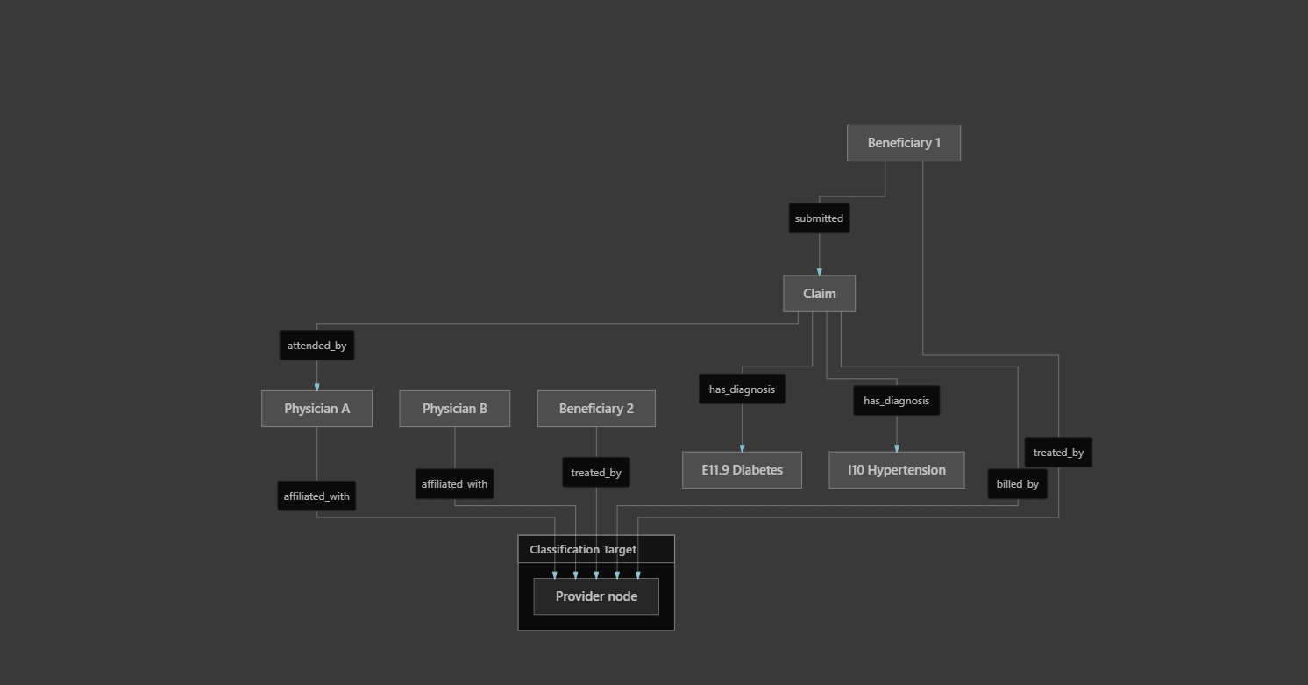

Each provider induces an ego-network of radius 2–3 hops. GNN readout pools claim/code/physician/patient signals into a provider embedding for PotentialFraud prediction.
Alternative: full heterogeneous graph
All entities in one graph (~700K+ nodes, ~2.5M+ edges). Better for transductive learning and anomaly detection across the full population; heavier computationally but feasible on modern GPUs.

Suitability Verdict
Criterion | Rating | Summary
Entity coverage | Good | Patient, claim, doctor (partial), treatment (proxy); no hospital
Graph constructability | Excellent | Rich multi-relational structure, large scale
Heterogeneous graph | Yes | 5–7 node types, 6+ edge types
Fraud labels | Partial | Provider-level train labels only; no claim labels; test unlabeled
GNN appropriateness | Yes | Strong fit for provider fraud; claim fraud requires weak-label or anomaly framing
Publication suitability | Moderate | Usable as benchmark, but saturated; needs methodological novelty + rigorous evaluation design
Bottom line: This dataset is suitable for your GNN + anomaly + explainability research if you align the task to provider-level fraud detection (or explicitly model claim labels as weak supervision) and address label ambiguity, class imbalance, and saturated-benchmark novelty in the paper design. It is not ideal if the core contribution requires explicit hospital nodes or adjudicated claim-level fraud ground truth.
If you want, I can next draft a concrete preprocessing + graph construction pipeline (PyG HeteroData schema) mapped to your 8-step project pipeline.

